# **Department of Computer Science and Engineering Islamic University of Technology (IUT)** A subsidiary organ of OIC

# 

# **Laboratory Report**

# CSE 4412 : Data Communication and Networking Lab

## 

## **Name: Md Muktadir Mazumder Student ID: 190042136 Section: Lab Group B Semester: 4th Semester Academic Year: 2020-21**

### **Title:** Understanding the basics of OSI layers.

### **Objective**:

1. Use the cisco packet tracer simulator to observe HTTP events..
2. Use the event details to check different tasks at different layers,

### **Devices/ software Used**:

1. Device : Personal Computer
2. Software : Cisco Packet Tracer

### **Working Procedure:**

Following steps are taken to complete the Experiment :

1. At first Simulation mode is selected from from Realtime Mode in Cisco Packet Tracer Software.

2. From the Event List Filters HTTP is selected.

3. Clicking on Web Client shows a new window.

4. Then Desktop tab is selected from the new Window.

5.After that, Web Browser was clicked.

6. Then [www.osi.local](http://www.osi.local) was entered in the URL and clicked on “Go” button.

7. By clicking Capture / Forward button four times, Network Events were observed.

**Diagram of the experiment:**

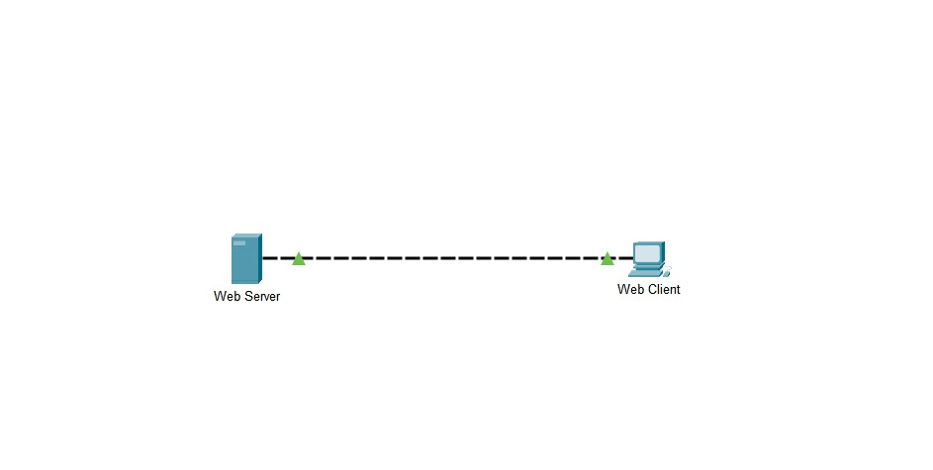

### **Observation**:

At the time of exploring the contents of HTTP packets from the event list, I observed there are four HTTP events taking place. I found notable findings in each of the event and explanation of the findings are listed below:

**Part 1:** **Examine HTTP Web Traffic**

The Web Client Web Browser page displays the dialogue “ You have successfully accessed the home page for Web Server.” , after the completion of the four Events shown on the Simulation Panel.

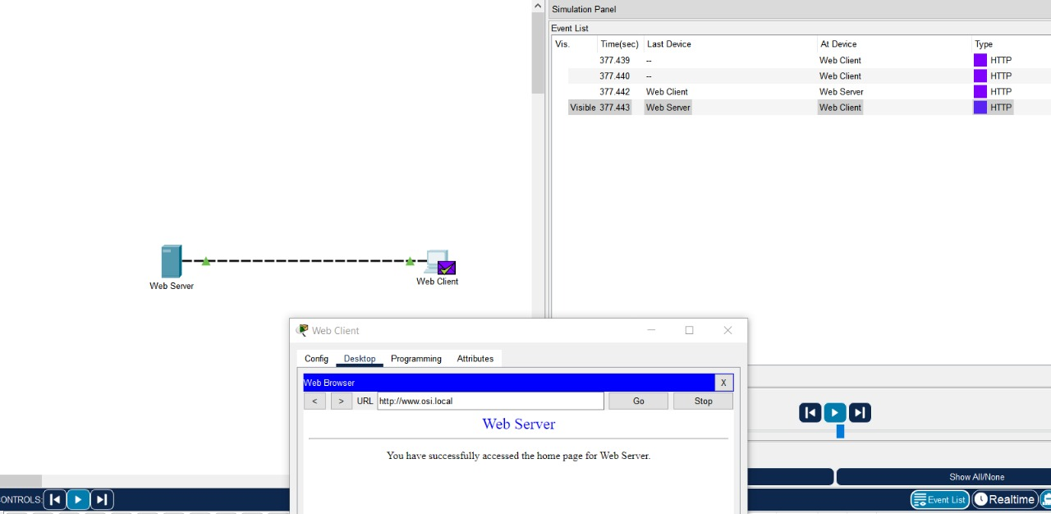

.

#### 

#### **1st HTTP Event:**

b) Text displayed next to the Layer 7 label is blank.

The information listed directly below the In Layers and Out Layers boxes is:

“The HTTP client sends a HTTP request to the server”.

c) The Dst Port Value in Layer 4 is 80

d) The Dest. IP Value in Layer 3 is 192.168.1.254

e) The informations displayed in next Layer i.e. Layer 2 are mentioned below:

1. The next-hop IP address is a unicast. The ARP process looks it up in the ARP table.

2. The next-hop IP address is in the ARP table. The ARP process sets the frame's destination MAC address to the one found in the table.

3. The device encapsulates the PDU into an Ethernet frame.

f) The common information listed under the IP section of PDU Details, as compared to the information listed under the OSI Model tab are given below:

SRC IP:192.168.1.1 and DST IP:192.168.1.254. These are associated with Layer 3.

The common information listed under the TCP section of PDU Details, as compared to the information listed under the OSI Model tab are given below:

SOURCE PORT:1030 and DESTINATION PORT:80. These are associated with Layer 4.

The Host listed under the HTTP section of the PDU Details is “[www.osi.local](http://www.osi.local)”.

This information would be associated with Layer 7 under the OSI Model tab.

#### **2nd HTTP Event:**

The device takes out this frame from the buffer and sends it.

FastEthernet0 sends out the frame.

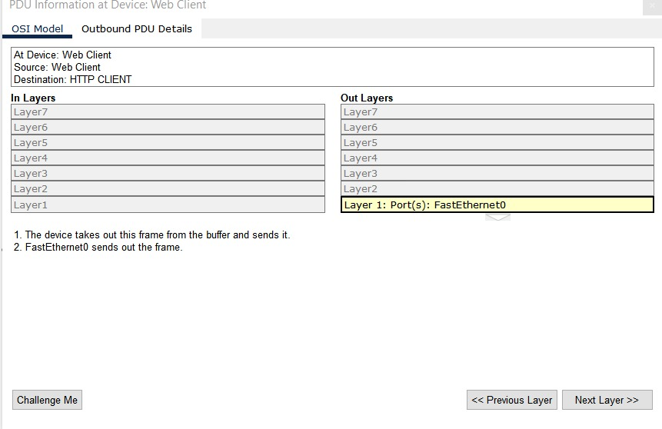

#### **3rd HTTP Event:**

h) The Major differences are given below comparing the information displayed in the In Layers column with that of the Out Layers are given below:

The Events previously displayed were of Layer 2 in the Out Layers.

The Src Port Address, Src IP Address and the Source Mac Address of the Out Layers becomes the Dst Port Address, Dest. IP Address and the Destination Mac Address of the In Layers. This scenario also happens to the Destination Addresses of the Out Layers and Source Addresses of the In Layers.

1. The first line in the HTTP message displays:

“HTTP Data:Connection: close”.

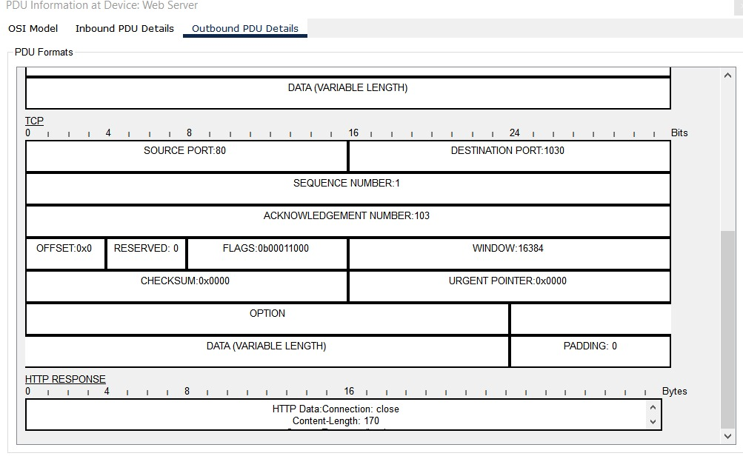

#### **4th HTTP Event:**

j) Only two tabs were displayed in this HTTP Event. The reason is that there is no Outbound Layers.

### **Challenges:**

By the Grace of Almighty, the experiment was successfully done. The working procedures were followed strictly and the HTTP Events were observed carefully. No challenges were faced during the observation, Alhamdulillah. The Cisco Packet Tracer software worked perfectly.